Proofs

1. Given: are right angles

Prove: 



2. *Given*: trapezoid *ABCD *and diagonals and  meet at *E.*

*Prove: *



3. *Given:* , , 

*Prove:* 



4. *Given: ,*

*Prove:* is an isosceles triangle

5. *Given:* *,* , and 

*Prove:*  bisects 



*6. Given:* , ,**, **

*Prove: AECF is a rectangle*



7. *Given:* 

*Prove:* is an isosceles triangle.



8. Given: Quadrilateral *QRST*



Prove: 

|  |  |  |
| --- | --- | --- |
| http://www.regentsprep.org/Regents/math/geometry/GP15/pracPr18.gif9 |  | http://www.regentsprep.org/Regents/math/geometry/GP15/PROOFPIC1.gif |
| http://www.regentsprep.org/Regents/math/geometry/GP15/PROOFPIC2.gifhttp://www.regentsprep.org/Regents/math/geometry/GP15/pracPr19.gif  10.  http://www.regentsprep.org/Regents/math/geometry/GP15/pracPr22.gif  http://www.regentsprep.org/Regents/math/geometry/GP15/PROOFPIC5.gif11.  http://www.regentsprep.org/Regents/math/geometry/GP15/PROOFPIC4.gif  http://www.regentsprep.org/Regents/math/geometry/GP15/pracPr15.gif  12.   |  |  | | --- | --- | |  |  |  |  |  |  | | --- | --- | --- | |  |  |  | |  |  | | | | | |

Coordinate Proofs

1. Given with coordinates,, and.

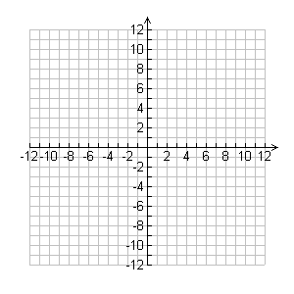 Graph  on the axes, and find the coordinates of the centroid of the triangle.

2. The coordinates of the vertices ofare A(-5,3), B(4,0), and C(0,4).

Find the coordinates of the orthocenter of the triangle.

**3.** The coordinates of the vertices of quadrilateral *ABCD* are , , , and.

a. Graph quadrilateral *ABCD* on the given axes.

b. Prove that *ABCD* is a rhombus.

c. Prove that *ABCD* is not a square.

4. Ex. The coordinates of the vertices of *ABCD* are , , , and .

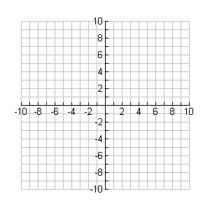a. Prove that *ABCD* is a rectangle

b. Find the coordinates of the intersection of the diagonals

c. The vertices of *A’B’C’D’ are ,and .* Under what specific transformation is *A’B’C’D’* the image of *ABCD*?

d. Prove that *A’B’C’D’* is a rectangle.

5. Quadrilateral GREG’ has vertices*: G(-4,-2), R(0,5), E(9,3),*  and *G’(7,-4).*

 Graph quadrilateral *GREG’* on the given axes and find the area of GREG’

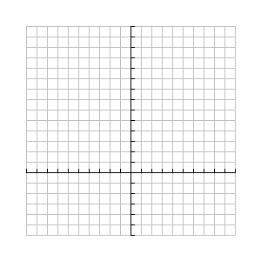6a. On the set of axes below, solve the following system of equations graphically for all values of x and y. Do not forget to write answer(s) as points of intersections.



b. Solve the system algebraically.